**Project Title:**  
*Data Leverage – Power Query Transformation Project*

**Objective:**  
The purpose of this project was to simulate a **data engineering scenario** in Power BI using the **Power Query Editor**. The focus was exclusively on **data extraction, cleaning, transformation, and integration** without the use of DAX or visualizations.

**Data Sources**

1. 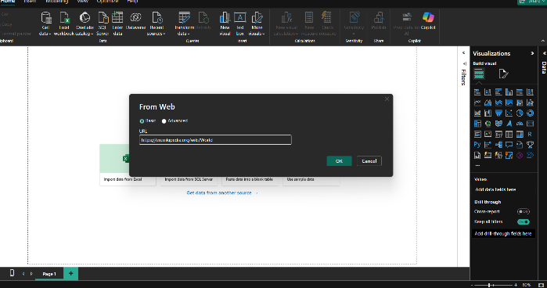**Web Source:** Wikipedia table (Country-wise GDP).

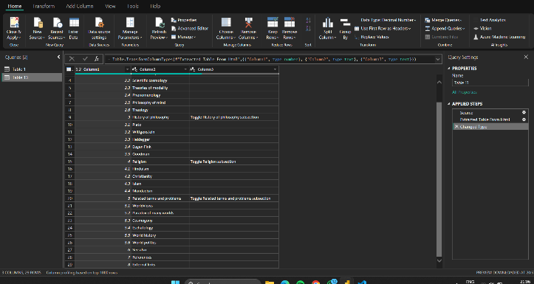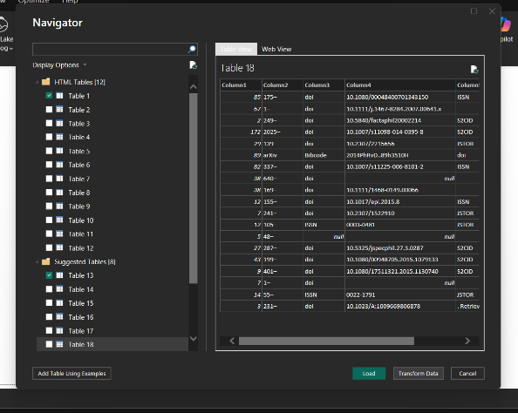

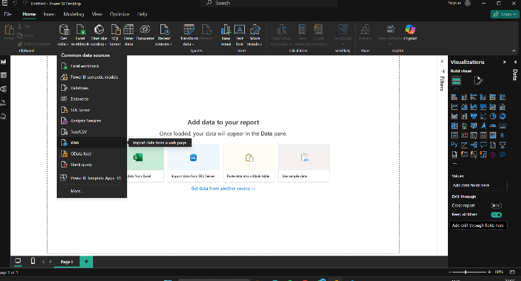

1. 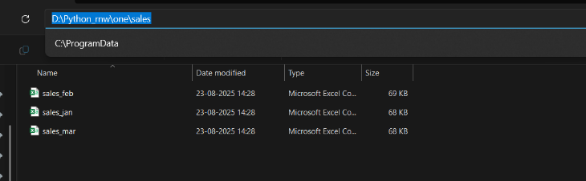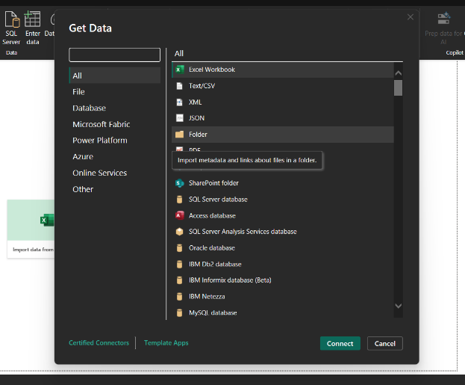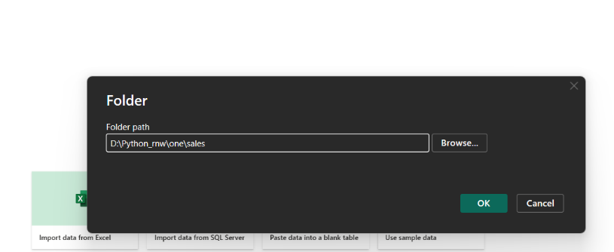**Folder Source:** Three Excel files (*Sales_Jan, Sales_Feb, Sales_Mar*).
2. 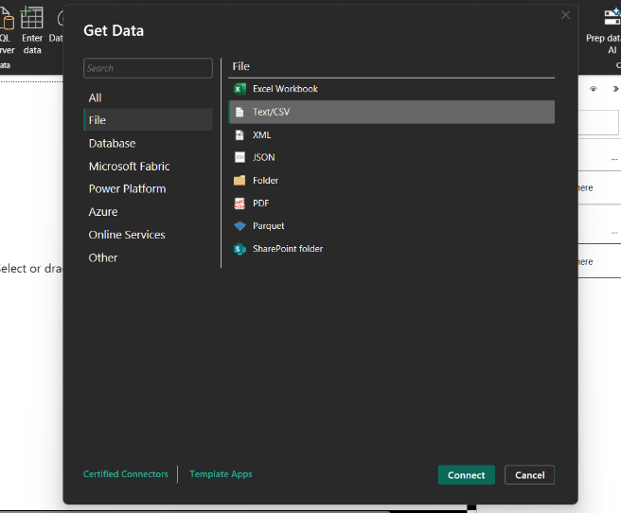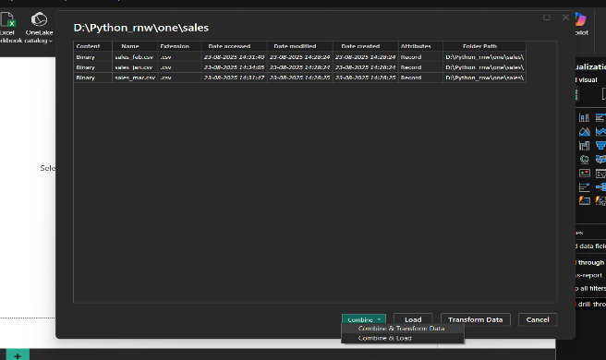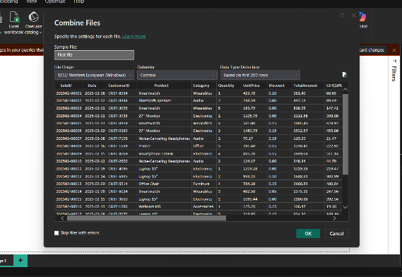**Excel File:** Employee dataset (EmpID, Name, Department, Region, Join Date).

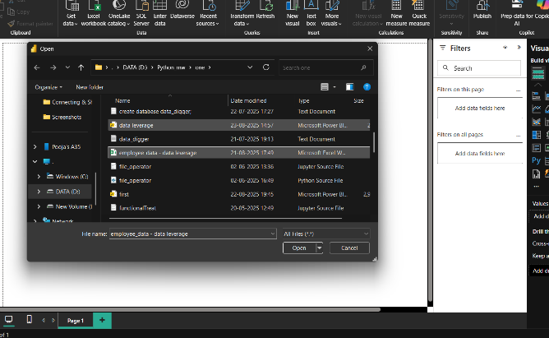

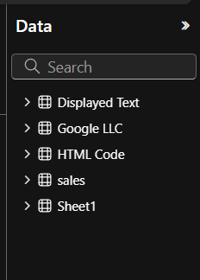

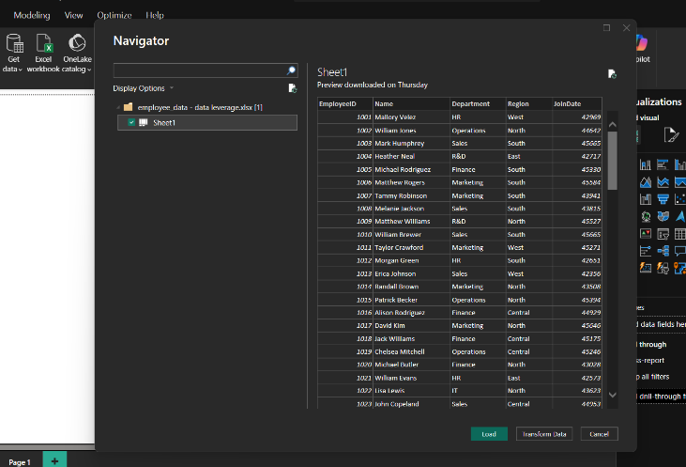

**Transformations Applied**

**1. Data Cleaning**

* 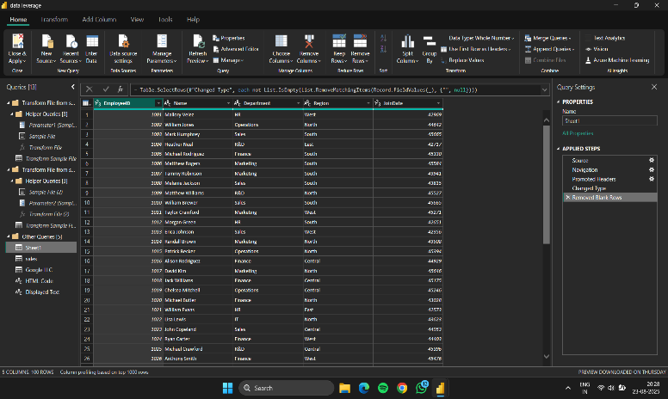Removed blank rows and null values.

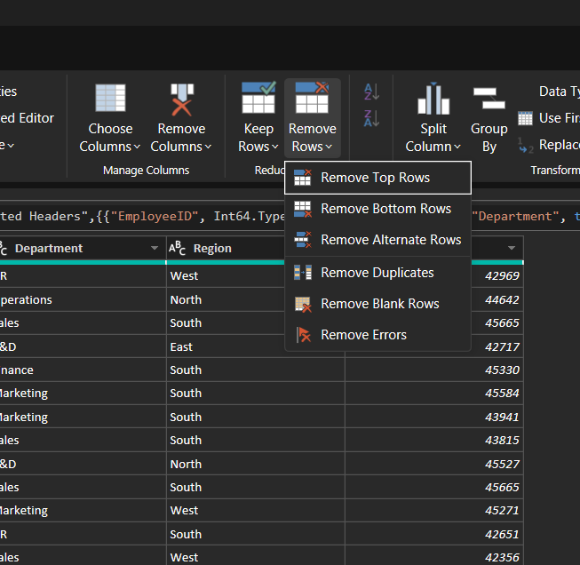

* Removed unnecessary columns (including fully blank columns).

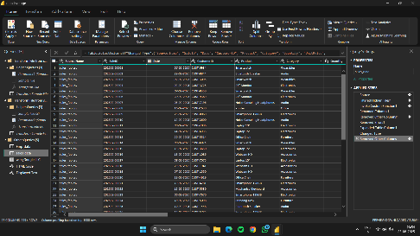

* Promoted headers.

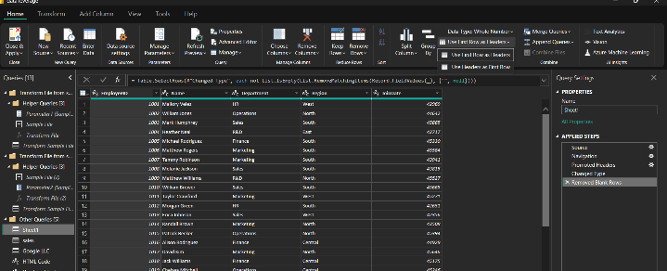

* Renamed columns with meaningful names.

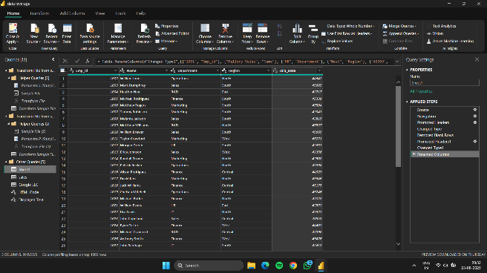

* Applied correct data types

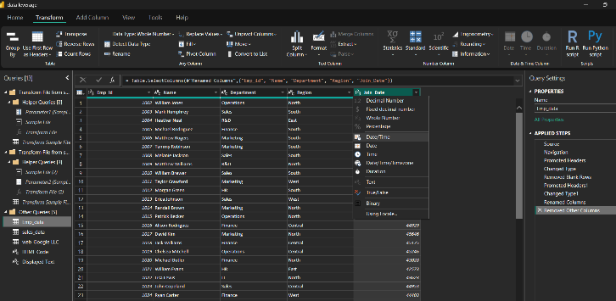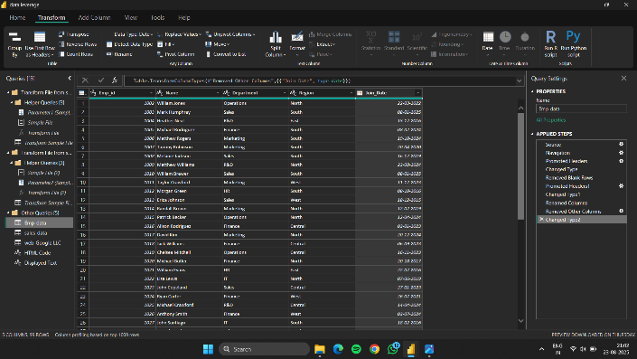

**2. Text Transformations**

* Standardized names and addresses with UPPER(), LOWER(), TRIM(), CLEAN().

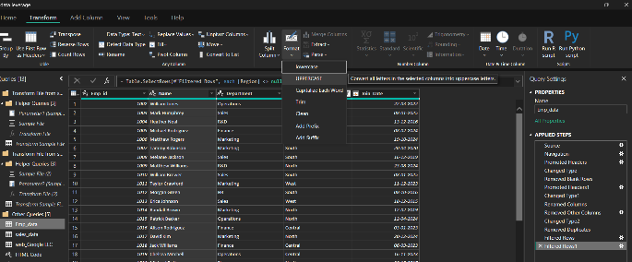

* Used REPLACE() to correct typos.

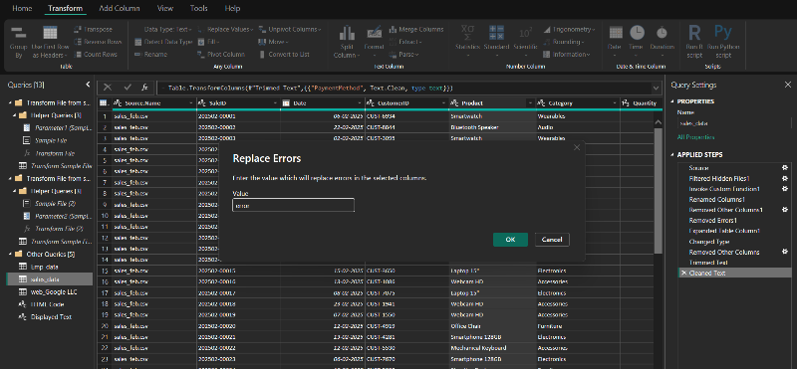

* Split address column by delimiter (e.g., city/state).

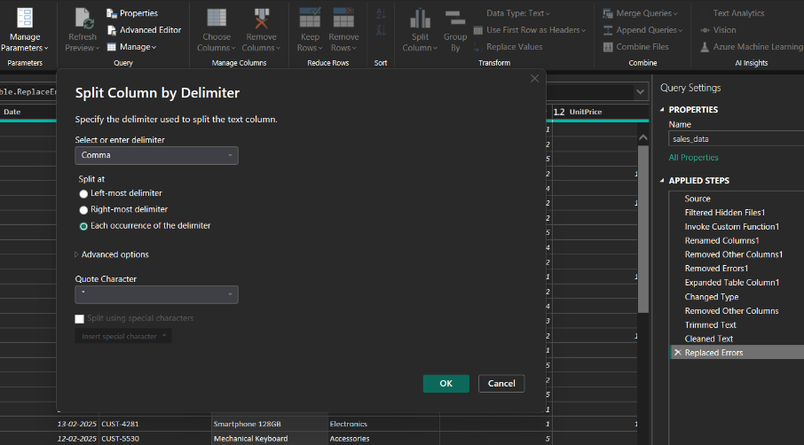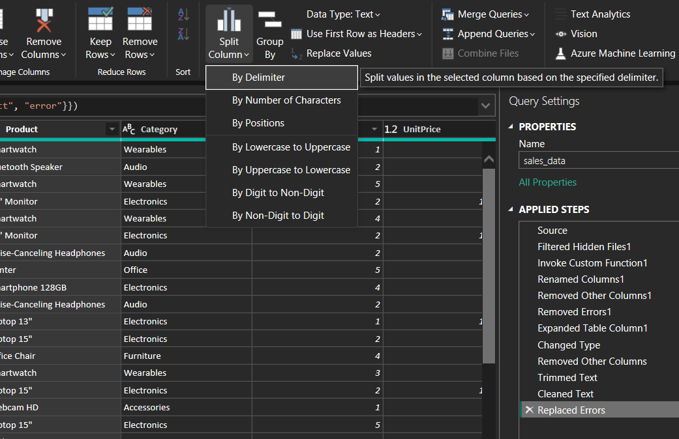

**3. Numeric Transformations**

* Rounded Revenue to 2 decimal places.

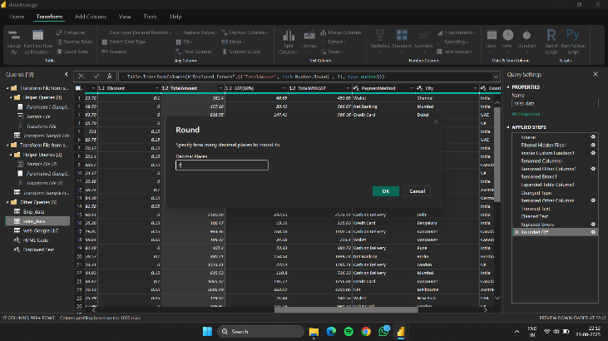

* Created new column **Amount_without_discount = Unit Price * Quantity**.

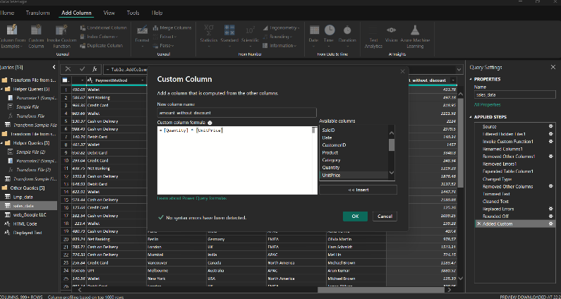

**4. Date & Time Transformations**

* Extracted Day, Month, Year, Quarter from Order Date.

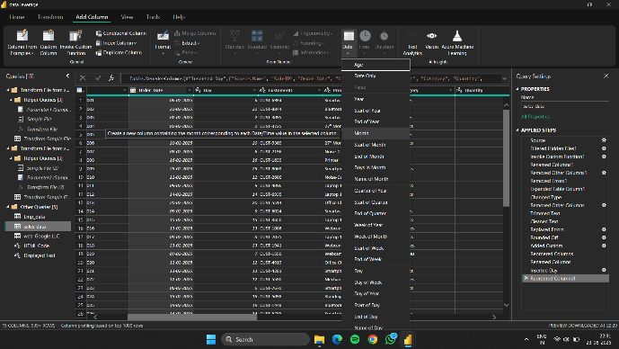

* Created **Fiscal Month** column with custom logic.

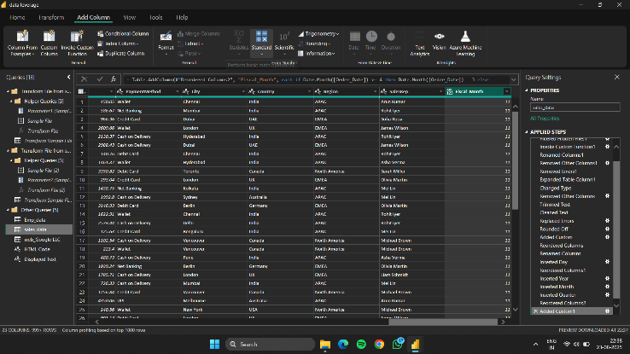

* 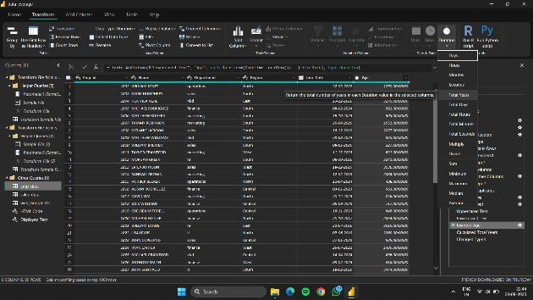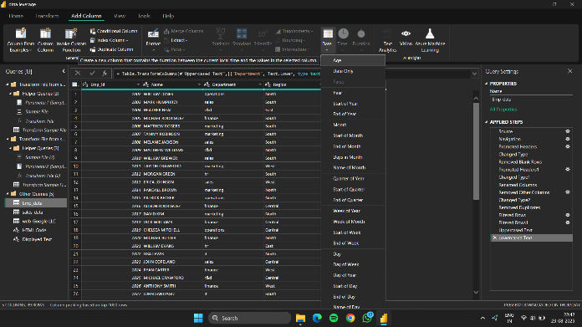Calculated **Joining** **Year** from **Join_date**.

**5. Conditional & Index Columns**

* Added **Total_amount** column: High, Medium, Low (based on revenue).

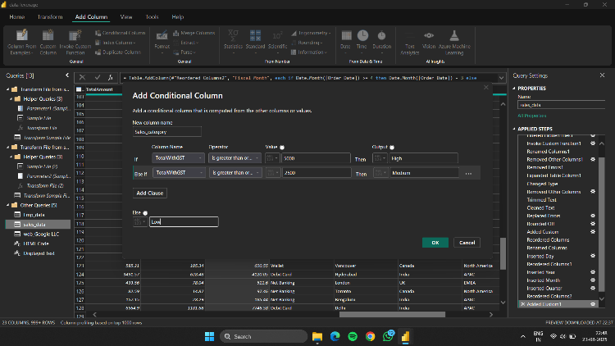

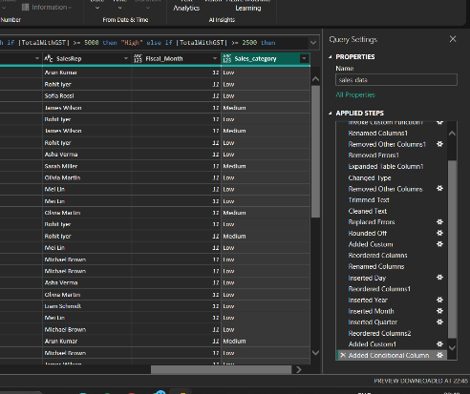

* Added Index columns (0-based and 1-based).

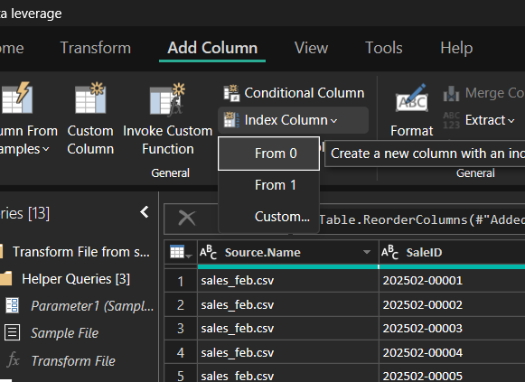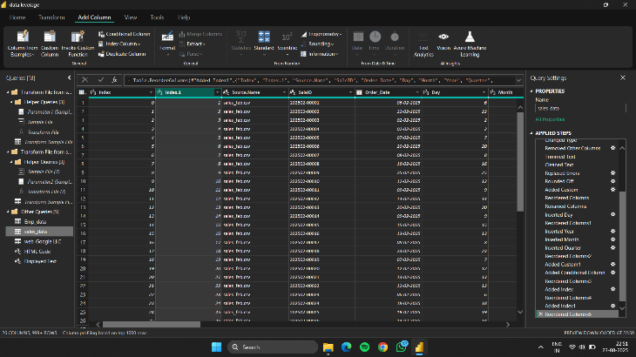

**6. Pivoting & Unpivoting**

* 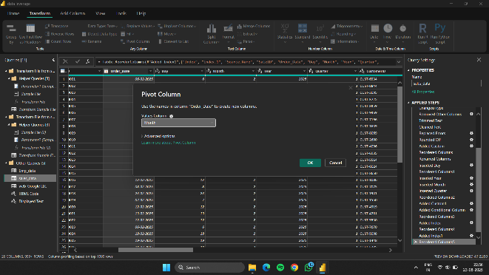Pivoted sales data into wide format.
* 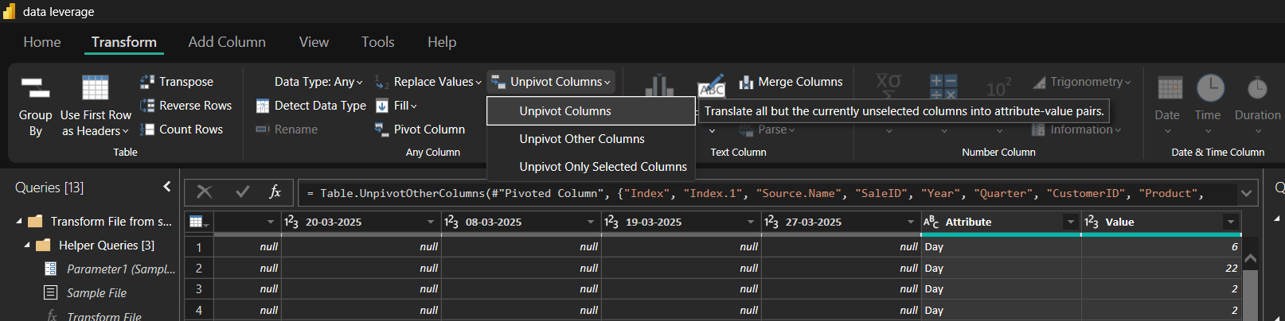Unpivoted data back into normalized long format.

**7. Merging & Appending**

* Merged Sales data with Employee data using Region/EmployeeID.

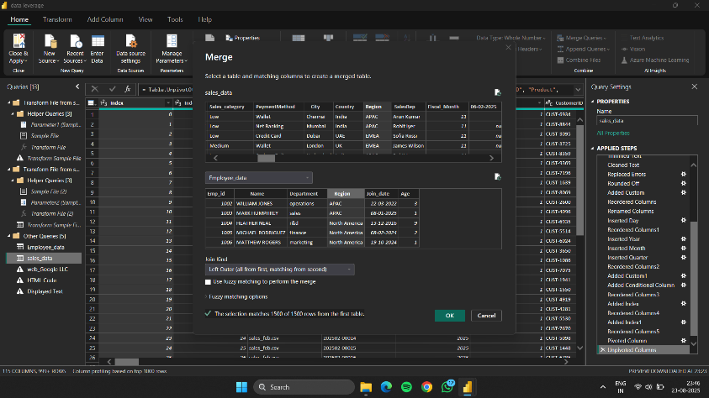

* Appended Sales_Jan, Sales_Feb, and Sales_Mar queries.

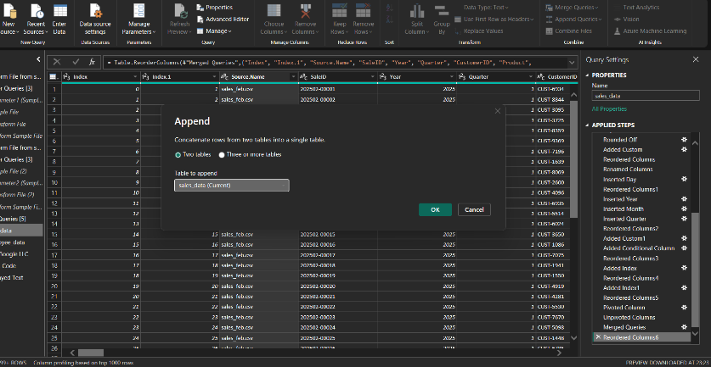

**8. Grouping & Aggregation**

* Grouped by Region to compute:
  + Total Sales
  + Average Order Value
  + 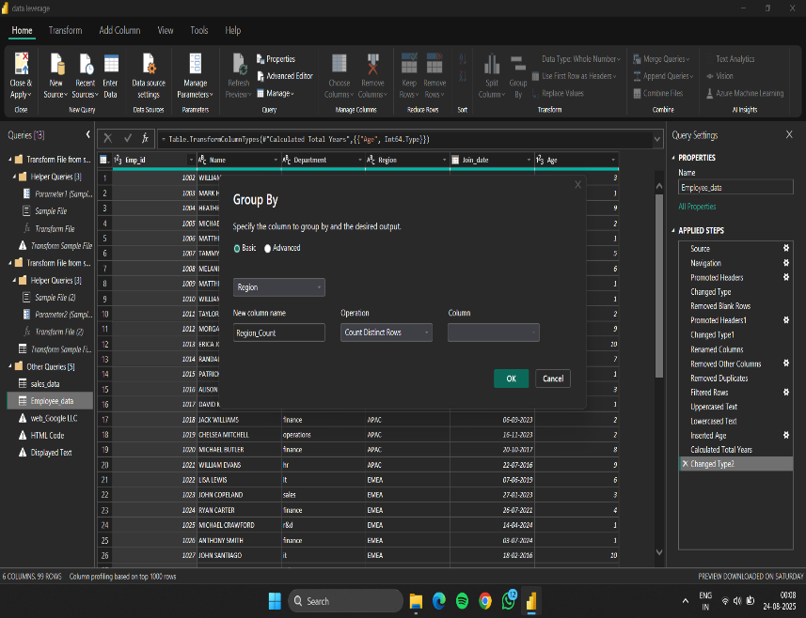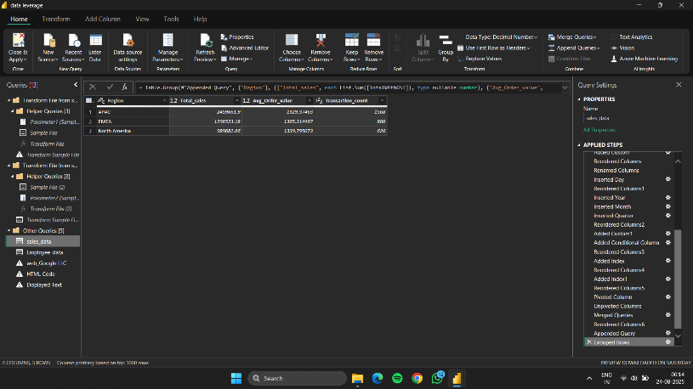Transaction Count

**9. Data Profiling & Quality**

* Used Column Profile, Column Quality, and Column Distribution to detect:
  + Missing values
  + Data type mismatches
  + Distinct/unique values

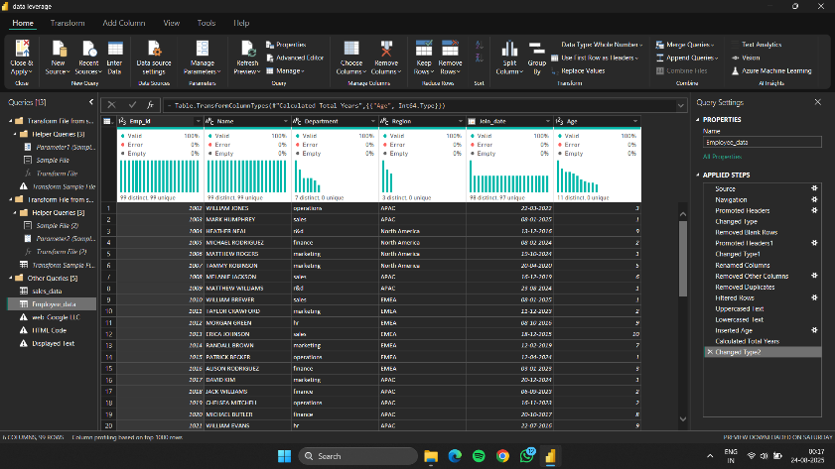

**10. Source Settings & Parameters**

* Created **parameterized folder path** for dynamic file loading.

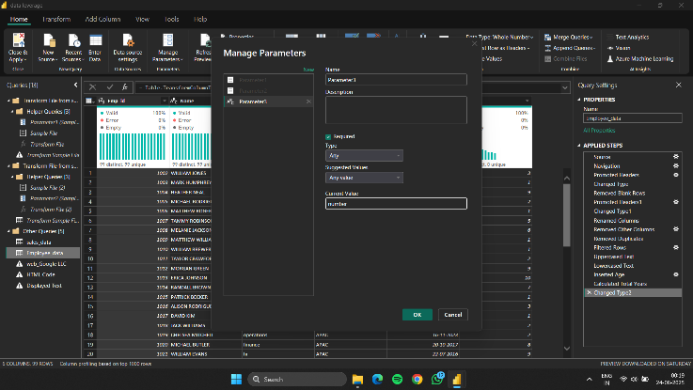

* Adjusted **Data Source Settings** for credentials.

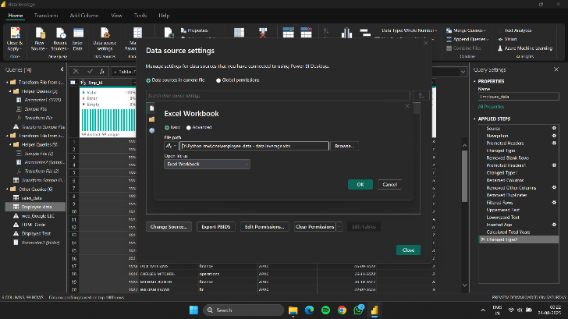

**11. Refresh Simulation**

* Added **Sales_Apr.xlsx** to the folder.
* Refreshed queries → data auto-loaded with transformations intact.

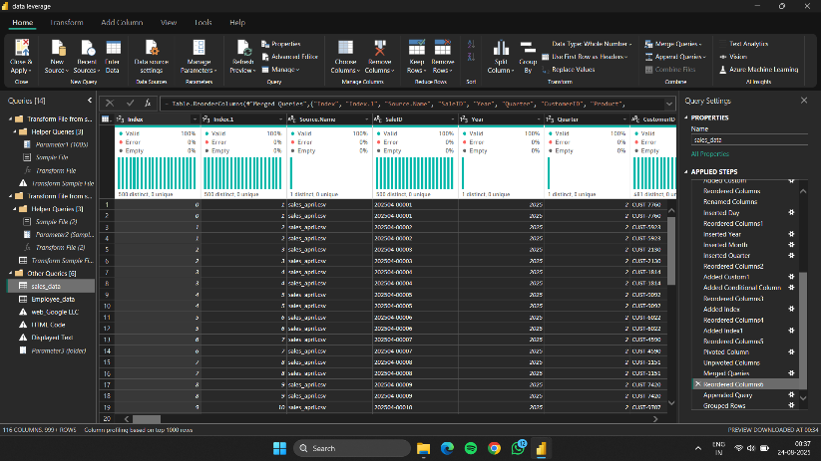

**Challenges Faced & Solutions**

1. **Blank Columns:** No direct “Remove Blank Columns” button in Power Query.
   * *Solution:* Removed manually and applied M-code to exclude fully null columns.
2. **Null Values:** Sales and Employee datasets contained missing IDs and dates.
   * *Solution:* Applied filters to remove (null) values from critical columns.
3. **Locale Issues in Currency/Date:** Different formats in source files.
   * *Solution:* Used **Change Type with Locale** for proper standardization.
4. **Refresh Simulation:** Initial refresh did not include new file.
   * *Solution:* Corrected parameterized folder path to auto-include new files.

**Conclusion**

This project demonstrated the **end-to-end ETL process** in Power Query:

* Extracting multiple data sources
* Cleaning and standardizing data
* Transforming text, numeric, and date fields
* Creating derived columns
* Merging and appending datasets
* Profiling and validating data quality
* Automating refresh with parameterized folder paths

The final dataset is now **clean, structured, and ready for analysis**.